Design of Place

Redevelopment of Napier University campus, Sighthill

Simon Brown
Filip Hegner
Simon Hindson
Lauren Hogarth
Rebecca Scott
Caroline Sumaric

Contents

Context Within the wider area

Design Proposals

Housing Mix and Tenure

Urban Design Strategy

Sustainability and Energy Efficiency

Landscape and Open Space; Views To and From the Area

Climate and Micro-Climate

Transport and Access

Border Links and Treatments

References

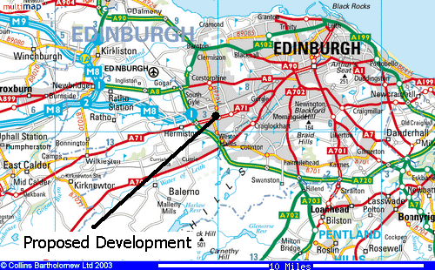

Context within the wider area

Sighthill is located in the west part of the city of Edinburgh. West Edinburgh forms a broad arc running from Crammond, and Granton Waterfront in the north through to the northern slopes of the Pentland Hills in the South. It extends form the edge of the inner city suburbs such as Gorgie in the east to the city bypass in the west. The population is approximately 155,000, comprising 64,000 households. Car and home ownership generally levels generally reflect the Edinburgh average (57% and 65%) respectively. Major business and industrial areas are located at Edinburgh Park and Sighthill.

Sighthill itself comprises in large of high density high rise flats, semi-detached and detached post-war housing both public and private sector. There are also been some recent housing development. Housing is generally low cost and much is of a poor, out-dated design quality.

Local amenities include a small number of local convenience shops within walking/cycling distance, including two garages, a Scotmid store, post-office and newsagents. Close to the site also is the Gyle shopping centre, Wester Hailes shopping complex and a large Tesco’s and other shopping amenities in the nearby Corstorphine. There is a health centre located beside the Napier site and the nearest hospital is the new Edinburgh Royal Infirmary in Little France.

There a number of schools in the local area including Sighthill Primary school, St Joseph’s RC school, Westburn Primary School an Longstone primary school. High Schools include Forrester High School and St Augustine’s High School.

Design proposals

See map 1.

The buildings of the Hyundai garage (which is the windiest part of the site) and the restaurant in the south part of the site are going to be preserved. The BP gas station is going to be demolished, and we propose there to be a small retail development built in its place. The new shops and the restaurant are going to form a pleasant and human friendly shopping precinct alongside Calder Road. There also will be a small car park serving the shopping area.
We propose there to be a residential area in the middle of the site. Smaller (2-storeys family houses, approximately 250 are on the south west, higher (3 storeys apartment blocks, approximately 48 flats in 8 buildings) on the northeast. This layout is according to the sunshine, a slope, and views from the site and the relation with the buildings on the east (where buildings are taller). The family houses in the western part should be of a good standard, the family houses in eastern part and tenements will contain smaller and economical flats.
The plots belonging to family houses will be private and fenced, cars are going to park on these plots to preserve the streetscape and keep the streets open. The area containing apartments is going to be open for public, children's playgrounds and greenery is also going to be located among buildings in this area. Some car parks for the apartment blocks will be in the area (especially for visitors), but it is recommended to build garages on ground floors of buildings or build underground car parks. The access to garages should preferably be from Sighthill Court.
The home for the elderly is located by the western border. This facility is needed in West Edinburgh. There is also going to be a little medical care for elderly and a private calm and restful garden in the area allocated to the home for the elderly. The height of buildings should be from 2 to 4 storeys there. A small car park for it is just by the entrance to the area.
It is recommended to form a green boundary along the western border of the site and plant out trees there as a natural barrier between the site and industrial on the west.
The Sports Centre is going to be preserved in the north part of the site but it has to be completely refurbished. The Sports Hall is going to be refurbished, new buildings and new playing fields and tennis courts are going to be built. The Sports Centre is going to be fenced, because of entrance fee, but it will serve to public from all surroundings. Car parks will be enlarged nearby.
The new and reconstructed buildings are going to be as more environmentally friendly as possible. Natural and user friendly materials (timber - floors, windows, roof truss) or cheap and functional materials and they should also be easily sought and produced using energy methods (plaster board – internal walls, etc.). The buildings should save energy as much as possible. A sufficient kind and sufficient amount of thermal insulation provides small thermal losses. Of course, the type of widows is very important, it is recommended to use double glazed windows for better thermal insulation. An environmentally friendly way of heating should be used for heating the sports centre, for example gas heating and possibly solar collectors as an addition (they could be installed on the roof to generate some amount of energy or provide partial heating of water).
There will be a park – open public space with greenery, benches, children's playgrounds, etc. – among the residential area, the home for the elderly and the Sports Centre and will serve to all these areas. It is very well hidden ahead of wind and also has a good connection with Sighthill Public Park. The park is going to serve to all occupants of new residential area, of all generations. It has to be a pleasant, calm and restful area for all of them there. The park’s boundaries with car parks and the Sports Centre have to be complimentary to all the uses – for example by barrier of shrubs or aesthetically pleasing (wooden) fences, etc. The road (going just to the car park in front of the House for Elderly) between the Park and the tenements’ area (where also open public area is) is going to be a “home zone street” (a street with a pedestrian priority). This road is going to make the spacing between the tenements’ area and the Park in order to make the Park sun shined as more as possible.
Main road for vehicles serving the site is Sighthill Court, which makes an eastern boundary of the site. The access to the site is from this road.
Main path for pedestrians is going right through the middle of the site, from the south to the north, through the middle of the shopping and residential area to the park, where it is divided for two directions – to the home for the elderly and to the sports centre.

Housing Mix and Tenure

The housing currently on the site is of poor quality and in disrepair and so must be demolished or heavily refurbished. The properties on the site are small houses that were the former homes of the caretakers for the Napier University building. In The surrounding area the housing is extremely varied, directly to the East of the site is two large tower blocks similar to each other and built from the same red brick as the Napier building one of which is on stilts, which, allows for people to pass below it rather than walk around. Across Calder Road is a selection of terraced and semi- detached two storey dwellings. Further toward the city centre on the left hand side of the road is a new development by Miller Homes consisting of a range of two, three and four bedroom homes and some low rise apartments which brings down the building line nicely from the high rise flats next to our site. Within the site we are wishing to develop the housing mix will be similar to that found within the miller homes site. Some of the houses are shown below as an artistic impression;

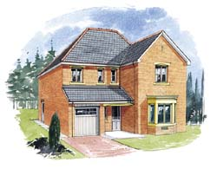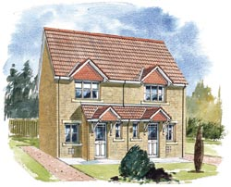

Both these types of houses on the left the Calder and on the right the Medway are included in the Miller Homes site named Westside Gardens.

The housing density on our site varies over the 3 separate residential areas, the first, behind the small shopping area, consists of a selection of two storey semi detached houses. The site directly behind this is where a selection of three storeys, low cost apartments which could be funded by the local authority or a housing association this would be a fairly high density part of the site compared with the two storey development closer to Calder road. Behind this we propose a residential home for the elderly. We suggest that this should be no more than three storeys in height and have a design which would compliment the other buildings on the site. A building such as the one which we believe would be suitable for the site has been built in Overijse, Brussels and is shown below;
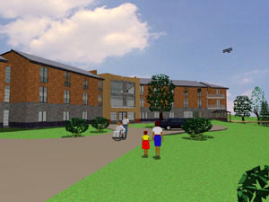

A maximum height of three storeys has been set for the residential home for three main reasons, if it needs to be evacuated not many stairs to move sick or infirm residents, the sun would not be blocked from the garden to the rear of the home and finally keeping it at three storeys keeps the building height inline with the rest of the site and does not obscure the views of the other residents on the site.

The first two residential parts of the site will be would be a mixture of low cost, socially rented housing and owner occupied housing. I feel it is important to mix the two different housing developments with low cost, social rented and owner occupied housing to encourage social inclusion on the site and within the wider area of Sighthill. Also by mixing the occupiers within the site allows the site to fit in with current government policy

The housing mix within the wider area currently does not really vary with the houses to the south of the site including those towards the Wester Hailes area are of a poor quality and are limited to a similar design and material usage. On the site we are promoting, we encourage the use of a wider range of materials as to vary the aesthetics of the area and to give the site a sense of renewal which may spread to the rest of the area to give the suburb a new identity.

The residential home for the elderly would be situated on the Western Edge of the site is shielded from the noise, dust and pollution of the factories by a lining of trees and shrubs. In front of the building, we suggest a small grassed area for residents to sit during the summer months so they are not always inside, although they do have the use of the open green a small distance away some residents may not be able to use it due to health restrictions, so a green outside would give them a chance to enjoy the outdoors. The dwellings within the site consisting of two storey buildings may have small gardens to the front and rear giving a private green for the residents of that dwelling. For the residents of the three storey dwellings a shared garden for each block would allow for some communal usage and encourage people to actively meet their neighbours.

The development of the two storey and three storey residential area covers land to the area of 13.6km². We recommend 25 two storey family homes and 8 three storey blocks of apartments giving a total of 48 apartments. Over a total area of 1.36 hectares this is recognised as higher density but is still lower than the Edinburgh City average of 118 dwellings per hectare. On our site the density is 53 dwellings per hectare.

As mentioned in Scottish Planning Policy 3 high density development should be encouraged on sites which are nearer to main transport exchanges and I believe that our site fits into this category and we recommend the second phase of the residential development should be quite high density but it should through good design avoid overcrowding. With this in mind we recommend making linkages to the nearby transport exchanges such as Calder Road, and the nearby South Gyle and Edinburgh Park train stations, as well as the major cycle routes and pedestrian walk ways. Sustainable modes of transport are encouraged via the walkways and cycle paths we propose run throughout the site and the non-removal of the bus stop which serves the site.

By proposing these residential units for the site we have made the assumption that the ground has enough load bearing capacity because of the buildings that are already located on the site, but we recommend that a full investigation of the soil and geology of the site is under taken before the building of any new dwellings. Also, we have discovered that there are no tunnels or mine workings underneath the site that may affect stability but the current foundations for the Napier University building run deep due to the large scale of the development and so we recommend that these are removed as they would be in the way of the development of the residential areas of this site.

In conclusion, I believe the housing that we propose for the site meets many requirements set out by Scottish Executive policy, mainly SPP3 – Planning For Housing and the guidance set out in PAN 67 – Housing Quality. The tenure of the dwellings is also in line with central and local government policy as it promotes social inclusion and allows for a mix of people to live within the site.

Urban Design Strategy

The site being distinctly Urban in its location and with its relation to the City of Edinburgh is an ideal site for residential/retail/recreational facilities and car parking facilities indeed, it lends itself as an ‘urban village’.

Land Use

The site has a good outlook to both south and north with southerly views of the local Pentland Hills and Corstorphine Hill to the north
The site has a slight downward slope from south to north and this natural land slope can be utilized at little cost to enhance the views from the residential areas of the development.
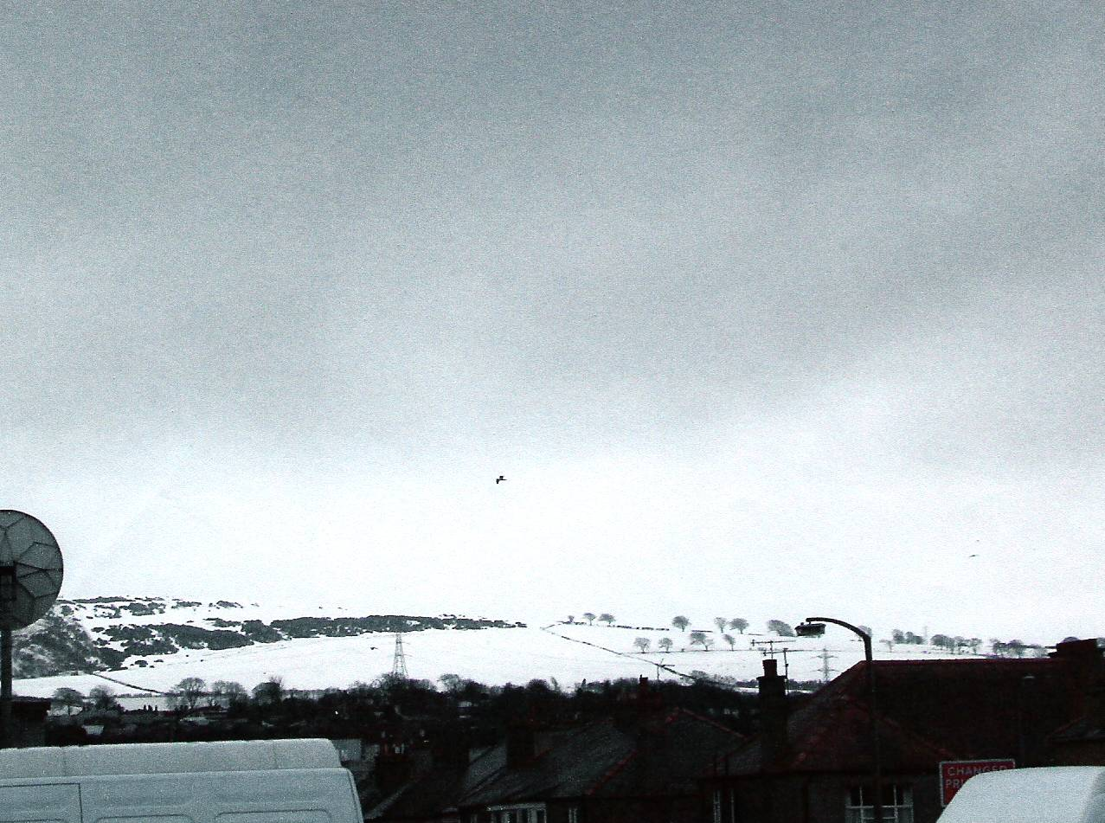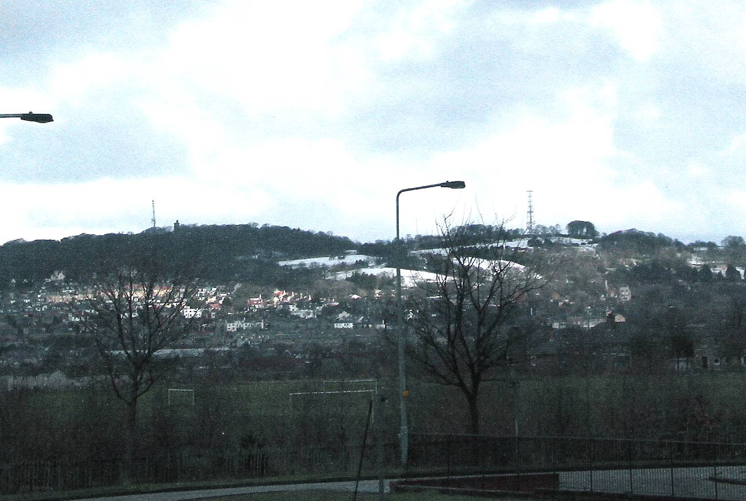
The site currently being used mainly as an area containing educational facilities has an existing infrastructure and these can also be utilized to a limited degree and thus reduce the capital expenditure.

Due to its size and strategic location, this site is crucial within the urban design framework of the Edinburgh West Area. Categorized broadly in the following two areas, the design for this development is required to;

- Create clear dense urban form with differing and defined characters along the edges of the site and within the development, providing and responding to differing models and types of urban living.
- Create and encourage connections and links between key points within and across the site to provide a permeable urban form, whilst also providing necessary defined private spaces for the residential units.

In response to these points, the master plan design strategy for this site seeks to provide the following:-

Building /Roof Lines

We would recommend strong linear building forms (backing on to the pavement) 2-3 stories fronting on to the main access road with the heights of the residential housing buildings and all buildings proposed for the site being restricted to two or at the most three stories to ensure that the prominent location does not restrict the open views described above and in line with national policy guidelines avoid over cramming in urban areas.

Urban residential blocks with private car parking below with access off the main access road facilitating easy pedestrian links and visual connectivity.

Landscape

The landscaping should clearly define public spaces with strong defining building forms built to back of pavement.
The landscaping of the development is of prime importance and we would recommend great care must be taken to provide a natural looking landscape throughout. We would suggest avoiding using prickly plants as these can hurt people but they may be used as part of a boundary treatment as this can help with security issues.

A children’s play area has been suggested. A safe amusement structure should be installed with ‘soft landing’ material such as tree bark being used.
As the site is fairly near the airport as the ‘crow flies’ the use of ponds must be carefully considered and avoid as far as possible the attraction of wild life which could endanger aircraft.

Materials

Planning policy guidelines also recommend the use of environmentally ‘friendly’ materials. For example materials which require no or minimal maintenance during the life span of the development would be desirable.

We would recommend that consideration is given to enhance the appearance of the look of the development by giving careful consideration to the external finishes of the buildings in that they blend together and are aesthetically pleasing. Different colours of facing brick could be used. We would like to suggest that to allow an Urban Village theme the possibility of using reconstituted stone in the construction. Slate roofs, timber windows, as a variation from the modern PVC and metal framed windows.

Below is a photograph of the use of reconstituted stone on a nearby site which is an environmentally friendly material;

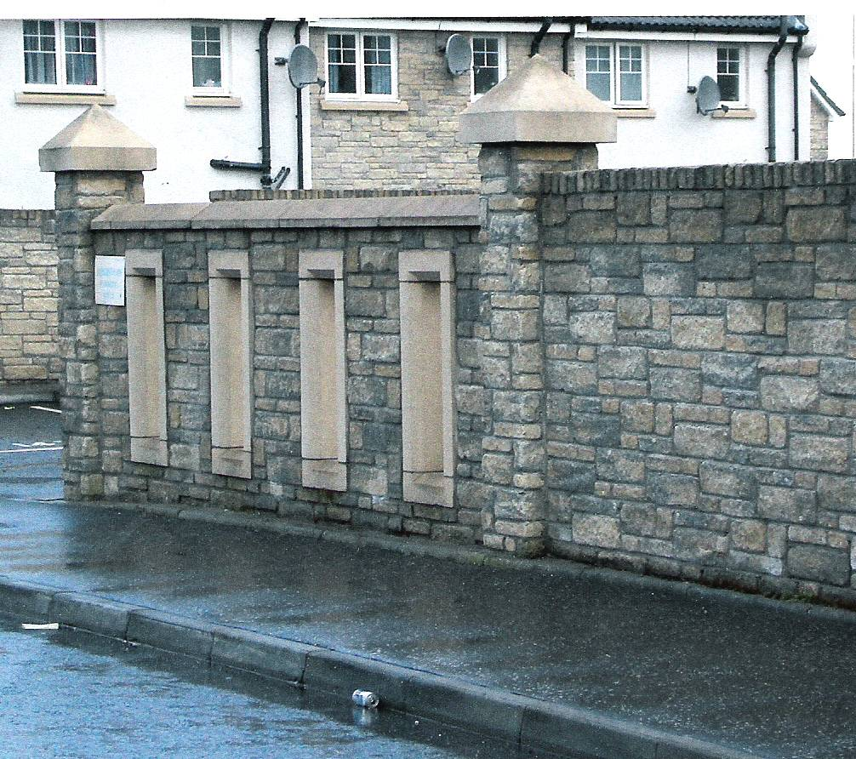

Following is a photograph taken in a development in near by Wester Hailes where different materials have been used to create a varied look on the estate;

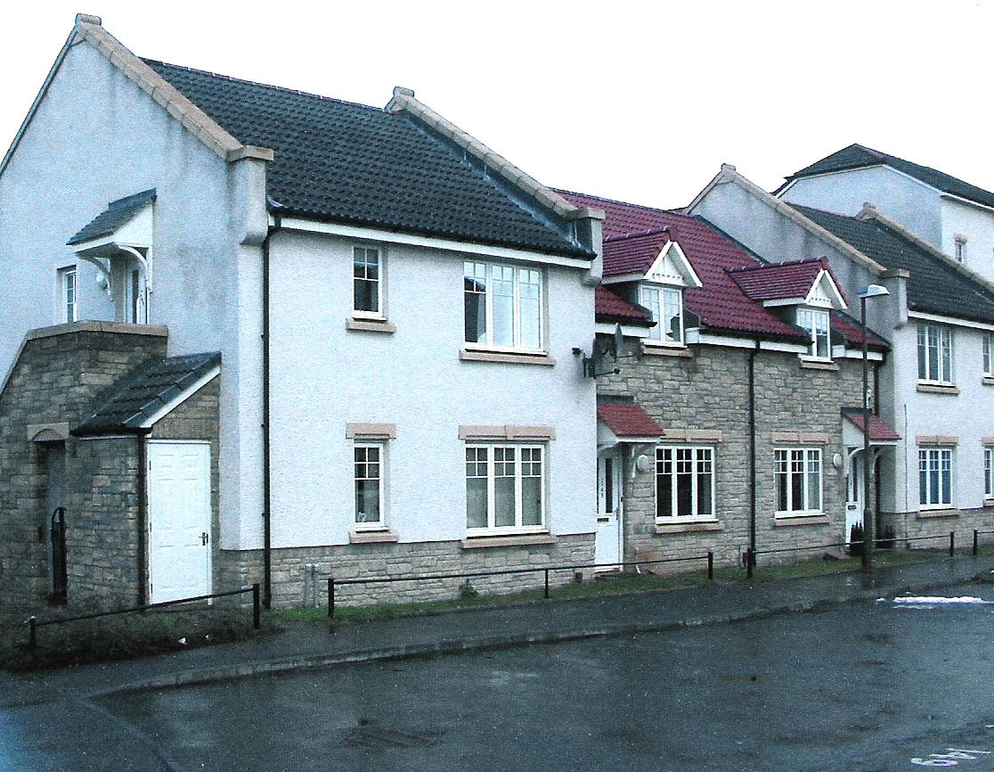

Security/Street-lighting/Street Furniture/Paving

Security is of utmost importance especially as the development contains residences for elderly people. The roadway layout should be such that there is only one main entrance/exit and this could be covered together with other vulnerable locations with the site by a C.C.T.V. system which would record all movements.

The location of these C.C.T.V. monitors must be carefully planned and not be a ‘blot on the landscape’ by being mounted on individual poles etc.

The street lighting whilst matching the surrounding area in colour should be restricted in height and the design in keeping with an ‘urban village atmosphere’. The use of low energy lighting fittings both in the street lighting and security lighting attached to buildings is extremely important from both maintenance and running cost aspect.

To ensure the urban village theme is achieved timber bench seating and occasional tables should be provided in the public areas and in appropriate street areas where practical.

The use of paving slabs should be avoided where possible as eventually they become uneven and this is not only a trip hazard but a maintenance item. Properly laid mono block paving would be better aesthetically and with the varying colours available presents the opportunity to obtain a pleasing contrast.

An important aspect of the paved areas is that they are designed both in size and strength to allow ready access to all buildings by a fire tender.

Sustainability aspects and energy efficiency

On a national level the environmental White Paper This Common Inheritance and the UK Sustainable Development Strategy identified as one of the Governments Key objectives the need “to increase the efficiency with which we use energy, at work and in our homes and in our cars and use public transport”.
NPPG3 also gives national guidance on energy efficiency stating that “In light of the wider environment concerns and a need to provide not only for the immediate requirements but also the longer term requirements of a residential area, new housing areas should be of a scale and the layout designed so as to be easily served by public transport, including rail”
NPPG3 also states that improving the micro-climate of built-up areas can also be a useful element in the overall approach to energy efficiency. Greater attention by developers to the layout, built form and landscape can create a sheltered micro-climate capable of making outdoor environments more habitable while also reducing the amount of energy needed to maintain acceptable internal conditions in buildings.

On a local level the Edinburgh city plan states that “developers will pursue high quality design standards in all new developments to achieve sustainable development objectives”.

Integrating energy efficiency and sustainability considerations into the design of the Napier site at Sighthill will meet both national and local guidelines and will be a key component contributing to good quality urban design.

Improving the micro-climate of built-up areas can also be a useful element in the overall approach to energy efficiency. Greater attention by developers to the layout, built form and landscape can create a sheltered micro-climate capable of making outdoor environments more habitable while also reducing the amount of energy needed to maintain acceptable internal conditions in buildings.

Site design and the layout can maximise solar gain, day lighting and shelter. To achieve energy efficiency you must consider insulation, ventilation, solar gain, day lighting, thermal mass, heating and control systems.

- By maximising glazing to the south (70:30 ratio South : North). Living areas should be located on South. Sun spaces and thermal buffers should be located on the south. Orientation of a building should be where possible within 30 degrees of South. As the sun rises in the east and sets in the west, passing South as it moves, any elevation facing north will not receive any sunlight directly into its walls. This can have a considerable affect on the amount of solar heat entering a building via the windows, depending on where the windows are located and their size.

- Protection from the wind through layout and design, and shelter provided from planting and natural features are part of a sustainable, good quality design.

- Minimum Insulation requirements are set in building regulations. The use of organic materials such as recycled paper can be used in consideration of walls, roof, floor, windows and doors.

- Ventilation can account for up to 25% of heat loss. There are between 3 and 5 air changes per hour in a traditionally built house. This can be less than 1 per hour in an efficient house.

- Renewable energy can be used where relatively small amounts of energy are needed. Solar power is the most readily available source in urban areas. Water/ evacuated air panels are the most useful in water heating and to some extent, space heating.

Landscape and open space; views to and from the area - present state

Description:
The site is approximately 300×180m, it is located in eastern part of Edinburgh by Calder Road. There is a garage, restaurant, gas station and a few family houses in the southern part, the buildings of University and Sports Hall occupy the main – northern - part of the site. There is one 7-storey high building and a few low rise buildings for the University; the sports hall has a circular shape and also a round roof. There are also two one-storey high buildings (one of which is the former students association), which look like provisional buildings and are unsightly. All buildings are in a state of disrepair as some have not bee used for over 2 years.
There are many parking areas, one on the eastern border (more than 100 parking places), another near the sports hall (approx. 160 parking places), and finally one behind the main university building (approx. 120 parking places). All of them are private, behind a fence, and are just asphalt surfaces without any greenery. There is also public parking area for customers nearby the restaurant (approx. 60 parking places).
There are only few trees, especially along western border; the rest of surface is just grass without any trees or shrubs.

Scale, Colours and Shapes:
The scale is inhuman; there are huge blocks of buildings and huge places among them. A man is lost in this space.
On the other hand a few family buildings in southern part are constrained together and have very small plots.
There are usually two colours on all buildings - grey of concrete and dark brown of glazed tiles. All buildings have shapes of blocks; just the restaurant and family houses in southern part have slanting roofs.
The open space on this site does not having any aesthetically pleasing qualities.

Character and Neighbourhood:
The character of the area is very disparate! The restaurant in old and classical style is nearby very ordinary and unsightly gas station and small and dilapidated family houses constrained together are nearby huge blocks of university buildings.
The area is connected with the main and busy Calder Road via a simple junction. There is another gas station (now out of order) and huge residential area behind the road. There are 3-storeys and 18-storeys tower blocks and also a health centre, fire station and library on the eastern side, Sighthill Public Park on the north-eastern side and Stevenson College on the northern side. There is a large industrial area behind western border of the site.

Public/Private Space:
The section of the site near Calder Road (garage, restaurant, gas station) is approachable for public. The site of the University is fenced together with the Stevenson College and is just for students and employees of the University.

Slope:
There is slope in south-east direction; the southern end is approximately about 8m above the northern end. The site is just about 62-70m above sea level.
The main slope is between family houses and main entrance to the University and continues below all University building. The areas around the restaurant and gas station and also around Sports Hall and parking areas are almost flat.

Views To and From the Area: see map 2
Family houses are seen on the south behind Calder Road. But the main view on the south is on beautiful Pentland Hills.
There is nothing special on the east, just high rise and low rise buildings, but there is nice view on north-east, above huge grass place with fields (Sighthill Public Park) on Corstorphine Hill and houses on its hillside. This is very fabulous view, and also view from Corstorphine Hill on Napier Site is very fine.
There is Stevenson College on the north, one building is 9-storeys high and others 2-storeys high. When good visibility is, the mountains on the north behind Firth of Forth are seen, and it is very lovely view on this mountainous landscape.
Some works are on the west of the site behind the fence. There is a mound and trees in front of the fence, which hide an unsightly view on this side.

Conclusions and Recommendations for New Design
It is necessary to give a human area to the site, therefore we recommend to demolish huge buildings of the University and build there smaller buildings (smaller volume and also height), closer to each other, and create smaller spaces between buildings for a better feeling of belonging to the area.
It is also necessary to use more colours and greenery. Buildings’ frontages should be more coloured (not just grey and brown) and public spaces (streets, parks, open spaces) should be full of trees and other greenery. It is recommended to form a green boundary along the western border of the site and plant out trees there as a natural barrier between the site and the industrial estate.
The slope is unfortunately down to the north, therefore is recommended to build lower buildings on the south and higher on the north of the site, because of sunshine. Of course, views on the Pentland Hills (south), Corstorphine Hill (northeast) and Highlands (north) should be put to use as more as possible.

Climate & Micro Climate

Sunlight

Nationally, Scotland has more cloud cover than the rest of the UK but still averages 1400 hours of sunlight per year. The hours of Sunlight Peak in May or June time, while the lowest figures tend to be recorded in December.

Rainfall

Although traditionally seen has recording high rainfall levels, Edinburgh and the Lothians fairs well, averaging around 800mm per year. Southern Scotland suffers around 9 days per year with thunder.

Wind

In Scotland, the prevailing wind comes from the South West, although this depends on many factors such as: passing weather systems, local topography and the built environment. The Pentlands affects wind in Edinburgh and Sighthill, for example, as does the Coast.

Many Atlantic depressions pass over Scotland, the consequences of which are higher than average winds and gales.

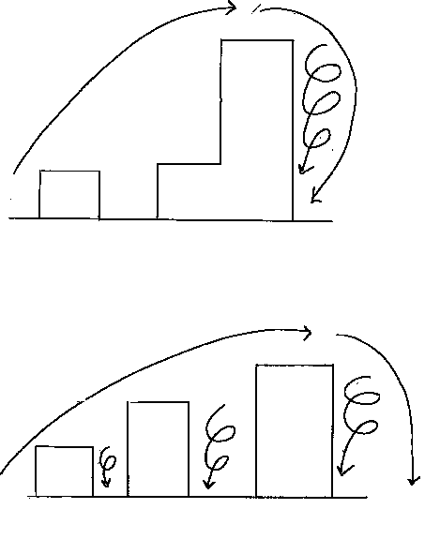

Above are diagrams demonstrating how wind moves past buildings and the vortex’s that can be created when the building height varies.

Temperature

January and February are the coldest months, and temperatures generally are a few degrees colder than Southern England. The average annual temperature is just above 9 degrees Celsius.

Snow

Snow is found more on higher ground, and is rarely found before November or after April at sea level lying areas. There can be extensive drifting of heavy snow. On the roads, lower lying roads are rarely affected by ice.

Visibility

Scotland as a whole enjoys excellent visibility, as it removed from densely populated areas and heavy industrial areas. However, low lying fog can be found, particularly around the Pentlands.

In summary, Sighthill has around 1400 hours of sunlight a year, while suffering approximately 800mm of rainfall a year. The prevailing wind is from the south west. The Pentlands, which Sighthill lies in the shadow of, and the North Sea, are factors that influence the weather of Edinburgh as a whole.

Transport and access

Public transport

Public transport is integral to any new development especially those that involve any kind of housing. As it promotes social inclusion, if a development did not have access to public transport then the poorer people in the development would be at a disadvantage as they wouldn’t be able to access any form of transportation as they probably don’t have private transport.

Airport
The development is within a ten minute car journey of Edinburgh airport and is within walking distance from the number 100 bus that goes to the airport.

Rail
The nearest major railway station is Haymarket and that is twenty minutes away by bus. There are minor railway stations at Wester Hailes, Edinburgh Park, South Gyle and Curriehill which are all within 10 minutes bus journey away and have access to the city centre.

Bus
The development would be within ten minutes walk of the new guided bus route between the city centre and Edinburgh Park. Edinburgh Park is one of the biggest employers in Edinburgh and any link to here would be beneficial to any housing development build in the area. The development would be on the Calder Road which has several bus routes traveling through it. This is one of the best bus links in the city as from here you can travel almost anywhere within the city.

Private Transport

Car
The proposed development would be next to the Calder Road which is one of the main roads into the city. The Calder Road is also less than 5 minutes away from the city bypass by car. Also by using the Calder road the city centre is accessible by car within fifteen minutes. Using the Calder road and the bypass any part of the city will be accessible.

Cycle
Cycling has an important role to play not just as a means of transport but also for leisure, recreation and countryside access. Cycling is also seen as a fast and efficient way of cutting through congestion. The Proposed development should be connected to the national cycle network, as this will lead to unlimited access by cycle anywhere within Scotland. To encourage people to use bicycles and to make it as safe as possible to do so the main roads in the area should have advanced stop lines, shared bus and cycle lanes and the proposed development should have adequate cycle racks.

Walking
Streets within the proposed development should provide a clean, secure and attractive environment for the pedestrian, e.g. better lighting so that people feel more secure and discourages crime and more pedestrian friendly road crossings, such as overpasses or underpasses.

Both private and public transport should be integrated so that the best possible transport service is provided. For example having cycle racks, adequate parking at train stations, airports and bus stations so that people have a choice of cycling, walking or driving to further transportation.

Streets and roads within the site
Streets within the site should be well lit to provide security and prevent crime. If possible C.C.T.V cameras should be provided to also help reduce any crime and fear the public may have of it. Streets should also be designed with children, the elderly, pedestrians and cyclists in mind. This will require street layouts that encourage these groups to move more freely and safely through residential areas. Other things such as 20 miles an hour speed zones and other traffic calming methods will help provide more safety for children playing around their homes and the elderly crossing the road as well as cyclists and other pedestrians.

Shown below are the main transport connections near the site;

Edinburgh Airport M8 to Glasgow Edinburgh Park Station South Gyle Station

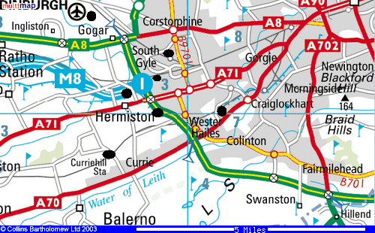

Edinburgh City Bypass Curriehill Station Wester Hailes Station Calder Road

Disability
All public buildings should have disabled access built to and within them to meet incoming disability legislation. For example they should have ramps for the walking impaired or those in wheelchairs as well as adequate disabled parking, disabled toilets and lower curbs to allow the walking impaired and wheelchair bound to travel across roads more easily.

Parking
Parking within the development should be adequate particularly in the vicinity of the home for the elderly. This should have a significant number of disabled parking spaces. Car parks should be well lit to avoid crime and to make people feel more secure. We recommend that the car parking for the three storey apartment blocks is built into the landscape as this would help to hide the cars on the development. A car park below the structure would be ideal but it must have access from Sighthill Court and must fit in well with the rest of the site with no bare faces on the buildings.

Access to the site
Any access to and from the site should be clearly marked with adequate signage. Access should also be provided for service vehicles, which are larger than most vehicles. This access should also include an area free of parking or obstruction outside any building it needs to access so that it may stop and complete its business.

References

Old folks home - http://www.idstudio.be/eng/projects/mariendal.html

Miller Homes - http://www.millerhomes.com

Edinburgh and Lothians Structure Plan 2001 Urban Capacity Study Summary of Findings - http://download.edinburgh.gov.uk/UCSsummaryrep_.pdf

The Role of the Planning System In The Provision Of Housing - http://www.scotland.gov.uk/cru/kd01/blue/rps-11.htm

